**My Journey in Developing a Note-Taking App with React and Firebase**

**Introduction**

Building a web application from scratch can be a daunting task, especially when you're diving into new technologies. In my recent project, I set out to create a note-taking app using React for the frontend and Firebase for the backend. This journey was both challenging and rewarding, and I had the invaluable assistance of ChatGPT, an AI language model by OpenAI, to guide me through the process. This is the story of how I learned to build my app, the questions I had along the way, and the solutions that helped me succeed.

**Getting Started with React**

**The Initial Concept**

I started with a simple idea: create a note-taking app where users can create, edit, and delete notes organized in notebooks. My initial challenge was choosing the right technologies. I decided on React for its component-based architecture and Firebase for its real-time database capabilities.

**Understanding React Components**

**Question:** What are React components, and why are they important?

ChatGPT explained that React components are the building blocks of a React application. Each component represents a part of the user interface, and these components can be reused throughout the application. I learned about functional components, which are JavaScript functions that return HTML-like syntax called JSX.

**Question:** How do I manage state in a React component?

To manage state within a component, I used the useState hook. For example, in my app, I needed to keep track of the notes and the currently selected notebook. Here's a snippet of how I used useState:

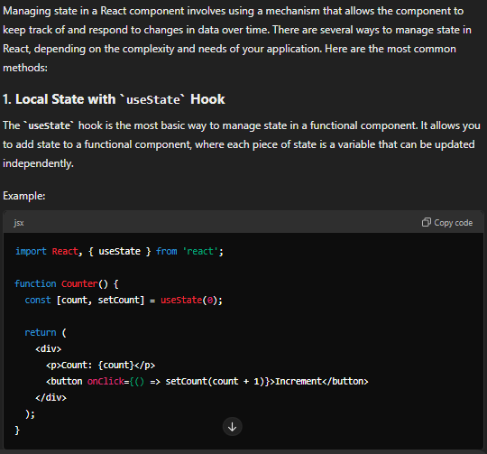**Integrating Firebase**

**Choosing Firebase**

I chose Firebase for its robust set of features, including authentication, Firestore for real-time data, and hosting. The next step was integrating Firebase into my React app.

**Question:** How do I set up Firebase in a React project?

ChatGPT guided me through the process:

1. **Create a Firebase Project:** I logged into the Firebase console and created a new project.
2. **Add Firebase to My Web App:** In the Firebase console, I found the configuration settings for my web app, which included the API key and project ID.
3. **Install Firebase SDK:** Using npm, I installed the Firebase SDK with the command npm install firebase.
4. **Initialize Firebase:**

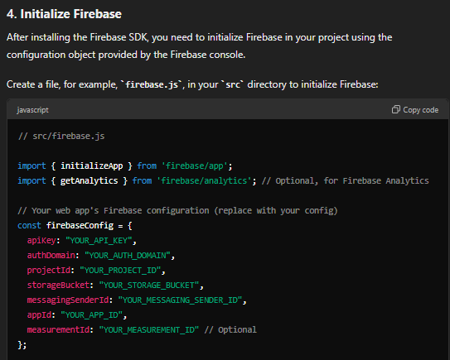

**Firebase Authentication**

**Question:** How do I implement user authentication with Firebase?

I wanted users to log in to their accounts to access their notes. ChatGPT suggested using Firebase Authentication, which supports various authentication methods, including email/password and Google sign-in. I opted for email/password authentication for simplicity.

**Firestore Integration**

**Question:** How do I store and retrieve data using Firebase Firestore?

Firestore is a NoSQL database that stores data in collections and documents. For my app, I created collections for notebooks and notes. ChatGPT helped me understand how to structure my data and use Firestore's API to interact with it.

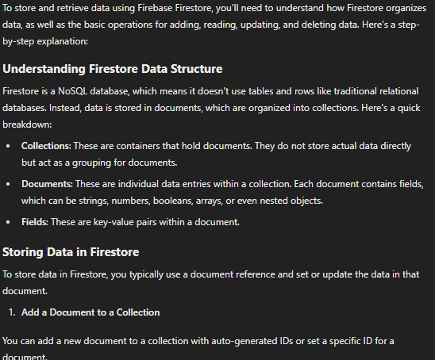import

**Handling Errors**

**Error Handling**

**Question:** How do I handle errors in my application?

As my app grew, I realized the importance of robust error handling. I learned to catch and handle errors gracefully, providing users with meaningful messages when things went wrong.

For example, when a user tries to access a note that doesn't exist, I wanted to display an error page. I implemented a global error handling mechanism using React's ErrorBoundary component with the help of the following explanation:

**Advanced Features and Final Touches**

**Versioning Notes**

**Question:** How can I implement version control for notes?

One of the more advanced features I wanted to add was version control for notes. This feature allows users to see the history of changes made to a note. ChatGPT helped me design a versioning system using Firestore's subcollections.



**Key Takeaways**

1. **React and Component-Based Architecture:** I learned the power of React's component-based architecture and how it helps in building scalable and maintainable applications.
2. **Firebase Integration:** Using Firebase for authentication and Firestore for real-time data storage was a game-changer, simplifying backend development.
3. **Error Handling :** I realized the importance of error handling and user experience in building a polished application.

**Final Thoughts**

This project was not just about building a functional app but also about the journey of learning and overcoming challenges. With each obstacle, I became more proficient in React, Firebase, and web development in general. The process reinforced the importance of perseverance and continuous learning in software development.

I'm grateful for the support and guidance from ChatGPT throughout this project. This experience has inspired me to continue exploring new technologies and tackling more complex projects in the future.